TOPIC 2 : BRUTE FORCE

- Write a program to perform the following
An empty list,A list with one element,A list with all identical elements,A list with negative numbers
Aim:
To create different types of lists.

Algorithm:
  - Create an empty list
  - Create list with one element
  - Create list with identical elements
  - Create list with negative numbers
  - Print all lists

Code (Python):
empty_list = [] one_element = [10]
identical = [5, 5, 5, 5]
negative = [-1, -2, -3, -4]

print(empty_list) print(one_element) print(identical) print(negative)

Implementation:
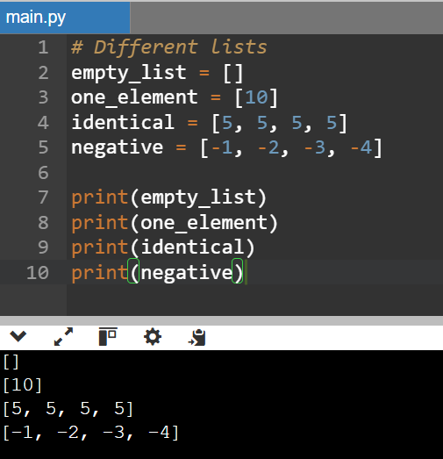

Result: Different types of lists are created successfully.

Describe the Selection Sort algorithm's process of sorting an array. Selection Sort works by dividing the array into a sorted and an unsorted region. Initially, the sorted region is empty, and the unsorted region contains all elements. The algorithm repeatedly selects the smallest element from the unsorted region and swaps it with the leftmost unsorted element, then moves the boundary of the sorted region one element to the right. Explain why Selection Sort is simple to understand and implement but is inefficient for large datasets. Provide examples to illustrate step-by-step how Selection Sort rearranges the elements into ascending order, ensuring clarity in your explanation of the algorithm's mechanics and effectiveness.
Aim:
To describe the process of the Selection Sort algorithm and its working.

Algorithm:
  - Consider the first element as the starting point
  - Find the smallest element from the unsorted part of the array
  - Swap it with the first unsorted element
  - Move the boundary of sorted part one step forward
  - Repeat the process until the entire array is sorted

Code (Python):
arr = [64, 25, 12, 22, 11]
for i in range(len(arr)): min_index = i
for j in range(i+1, len(arr)): if arr[j] < arr[min_index]:
min_index = j
arr[i], arr[min_index] = arr[min_index], arr[i] print(arr)

Implementation:
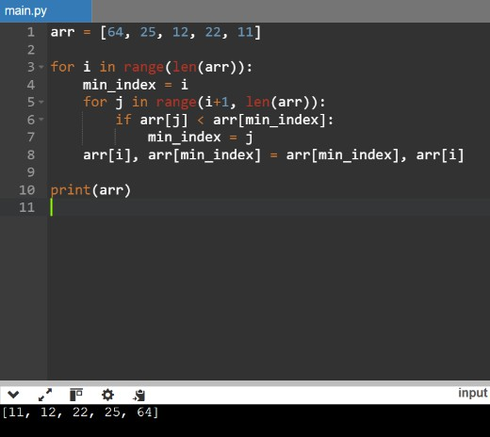

Result: Selection Sort arranges the elements in ascending order successfully.

- Write code to modify bubble_sort function to stop early if the list becomes sorted before all passes are completed.

Aim:
To modify the Bubble Sort algorithm to stop early if the list is already sorted.

Algorithm:
  - Start Bubble Sort from the first element
  - Compare adjacent elements and swap if needed
  - Use a flag variable (swapped) to track if any swap happens
  - If no swaps occur in a pass, stop the algorithm early
  - Repeat until the list is sorted or no swaps happen

Code (Python):
def bubble_sort(a):
for i in range(len(a)):
if not any(a[j] > a[j+1] and (a. setitem (j, a[j+1]), a. setitem (j+1, a[j])) for j in range(len(a)-i-1)):
break return a

print(bubble_sort([5, 1, 4, 2, 8]))

Implementation:
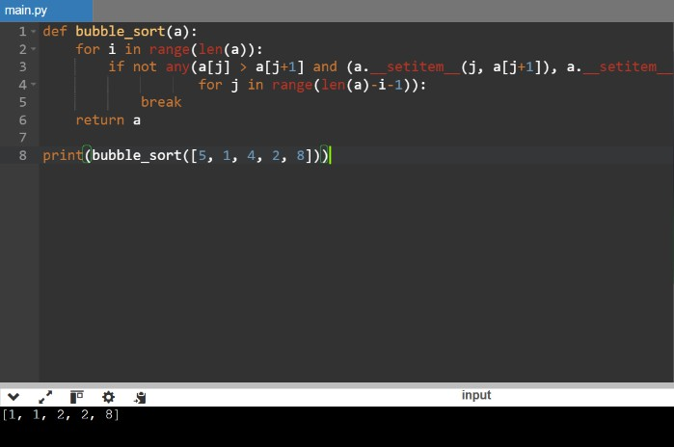

Result: The modified Bubble Sort stops early when the list becomes sorted, improving efficiency for already sorted or nearly sorted lists.

Write code for Insertion Sort that manages arrays with duplicate elements during the sorting process. Ensure the algorithm's behavior when encountering duplicate values, including whether it preserves the relative order of duplicates and how it affects the overall sorting outcome.
Aim:
To implement Insertion Sort that handles duplicate elements and maintains their relative order.

Algorithm:
  - Start from the second element of the array
  - Compare it with previous elements
  - Shift elements greater than the key to the right
  - Insert the key in the correct position
  - Repeat for all elements
  - Duplicates are not swapped unnecessarily → order is preserved

Code (Python):
def insertion_sort(a):
for i in range(1, len(a)): key, j = a[i], i-1
while j >= 0 and a[j] > key: a[j+1] = a[j]
j -= 1
a[j+1] = key return a
print(insertion_sort([5, 3, 5, 2, 3]))

Implementation:
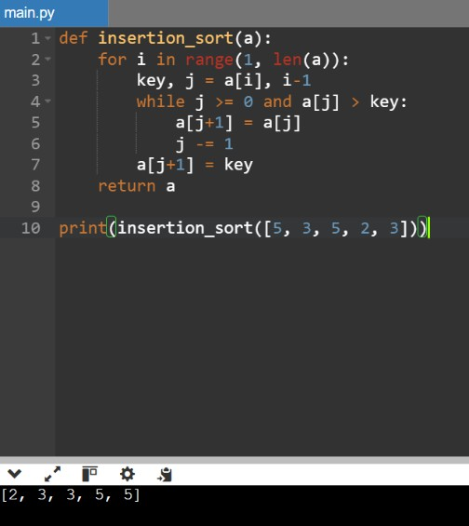
Result: Insertion Sort successfully sorts arrays with duplicate elements while preserving their original order (stable sorting).

Given an array arr of positive integers sorted in a strictly increasing order, and an integer k. return the kth positive integer that is missing from this array.
Aim:
To find the kth missing positive number from a sorted array.

Algorithm:
  - Start from number 1
  - Traverse the array and compare expected numbers
  - If a number is missing, decrease k
  - When k becomes 0, return that missing number
  - If not found within array, continue after last element

Code (Python):
def findKthPositive(arr, k): cur = 1
i = 0
while k > 0:
if i < len(arr) and arr[i] == cur: i += 1
else:
k -= 1
if k == 0: return cur
cur += 1
print(findKthPositive([2,3,4,7,11], 5))

Implementation:
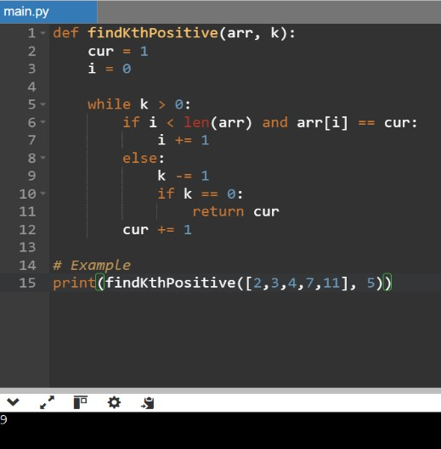
Result: The kth missing positive number is found successfully.

- A peak element is an element that is strictly greater than its neighbors. Given a 0-indexed integer array nums, find a peak element, and return its index. If the array contains multiple peaks, return the index to any of the peaks. You may imagine that nums[-1] = nums[n] = -∞. In other words, an element is always considered to be strictly greater than a neighbor that is outside the array. You must write an algorithm that runs in O(log n) time.

Aim:
To find a peak element index in an array using an O(log n) algorithm.

Algorithm (Binary Search):
  - Set low = 0, high = n-1
  - Find mid = (low + high) // 2
  - If nums[mid] > nums[mid+1], peak is on left (including mid)
  - Else, peak is on right side
  - Repeat until low == high
  - Return low (peak index)

Code (Python):
def findPeakElement(nums): l, r = 0, len(nums) - 1 while l < r:
m = (l + r) // 2
if nums[m] > nums[m + 1]: r = m
else:
l = m + 1 return l
print(findPeakElement([1, 2, 3, 1]))

Implementation:
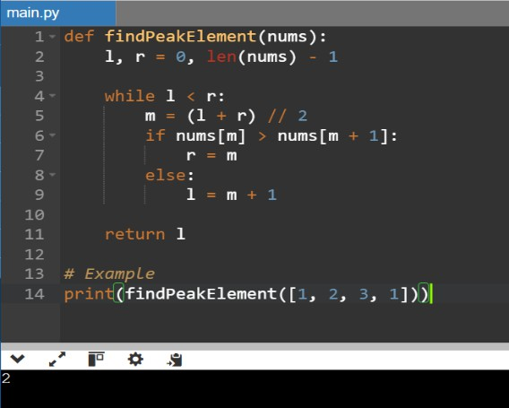
Result:Peak element index is found efficiently using binary search in O(log n) time.

Given two strings needle and haystack, return the index of the first occurrence of needle in haystack, or -1 if needle is not part of haystack.

Aim:
To find the first occurrence of a substring (needle) in a string (haystack).

Algorithm:
- Traverse the haystack string
- For each position, compare substring with needle
- If match found, return index
- If no match found, return -1

Code (Python):
def strStr(haystack, needle):
for i in range(len(haystack) - len(needle) + 1): if haystack[i:i+len(needle)] == needle:
return i return -1

print(strStr("hello", "ll"))

Implementation:
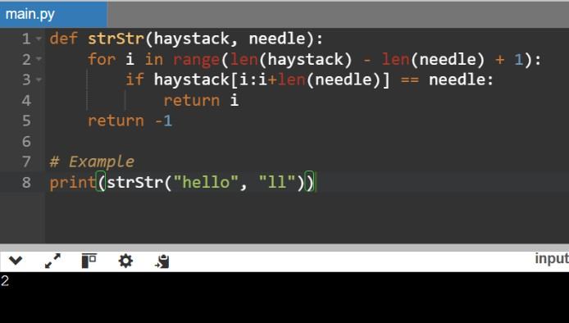

Result: The index of the first occurrence of needle in haystack is found successfully.

Given an array of string words, return all strings in words that is a substring of another word. You can return the answer in any order. A substring is a contiguous sequence of characters within a string

Aim:
To find all strings in an array that are substrings of another string in the same array.

Algorithm:
- Take each word from the list
- Compare it with every other word
- Check if it is a substring of another word
- If yes, add it to result list
- Return the result

Code (Python):
def stringMatching(words): res = []
for i in range(len(words)): for j in range(len(words)):
if i != j and words[i] in words[j]: res.append(words[i])
break return res

print(stringMatching(["mass","as","hero","superhero"]))

Implementation:

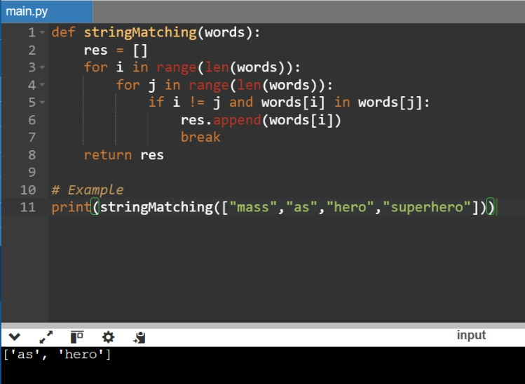

Result: All strings that are substrings of another word are returned successfully.

Write a program that finds the closest pair of points in a set of 2D points using the brute force approach.

Aim:
To find the closest pair of points in a 2D plane using brute force approach.

Algorithm:
- Take all pairs of points
- Calculate distance between each pair
- Keep track of minimum distance
- Store the pair with smallest distance
- Return the closest pair and distance

Code (Python):
from math import hypot

def closest_pair(p):
m, pair = float('inf'), None for i in range(len(p)):
for j in range(i+1, len(p)):
d = hypot(p[i][0]-p[j][0], p[i][1]-p[j][1]) if d < m: m, pair = d, (p[i], p[j])
return pair, m print(closest_pair([(2,3),(12,30),(40,50),(5,1),(12,10),(3,4)]))

Implementation:

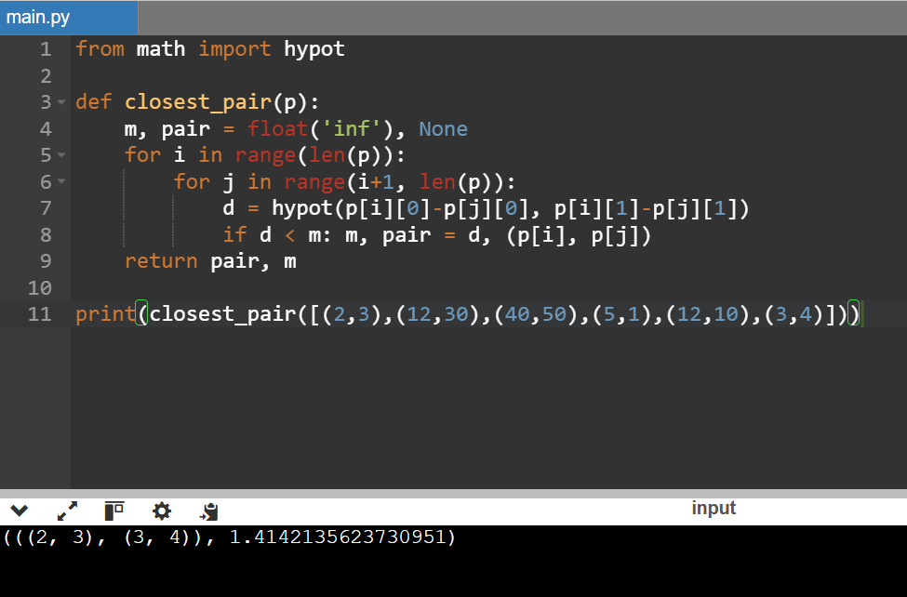

Result: The closest pair of points and their minimum distance are found successfully using brute force method.

  - Write a program to find the closest pair of points in a given set using the brute force approach. Analyze the time complexity of your implementation. Define a function to calculate the Euclidean distance between two points. Implement a function to find the closest pair of points using the brute force method. Test your program with a sample set of points and verify the correctness of your results. Analyze the time complexity of your implementation. Write a brute-force algorithm to solve the convex hull problem for the following set S of points? P1 (10,0)P2 (11,5)P3 (5, 3)P4 (9, 3.5)P5 (15, 3)P6 (12.5, 7)P7 (6,
6.5)P8 (7.5, 4.5).How do you modify your brute force algorithm to handle multiple points that are lying on the sameline?

Aim:
To find the closest pair of points using brute force, analyze time complexity, and solve convex hull using brute force.

Part 1: Closest Pair (Brute Force) Algorithm:
- Check all pairs of points
- Compute Euclidean distance
- Track minimum distance
- Return closest pair

Code (Python):
from math import hypot

def closest_pair(p):
m, pair = float('inf'), None for i in range(len(p)):
for j in range(i+1, len(p)):
if (d := hypot(p[i][0]-p[j][0], p[i][1]-p[j][1])) < m: m, pair = d, (p[i], p[j])
return pair, m print(closest_pair([(2,3),(12,30),(40,50),(5,1),(12,10),(3,4)]))

Implementation:

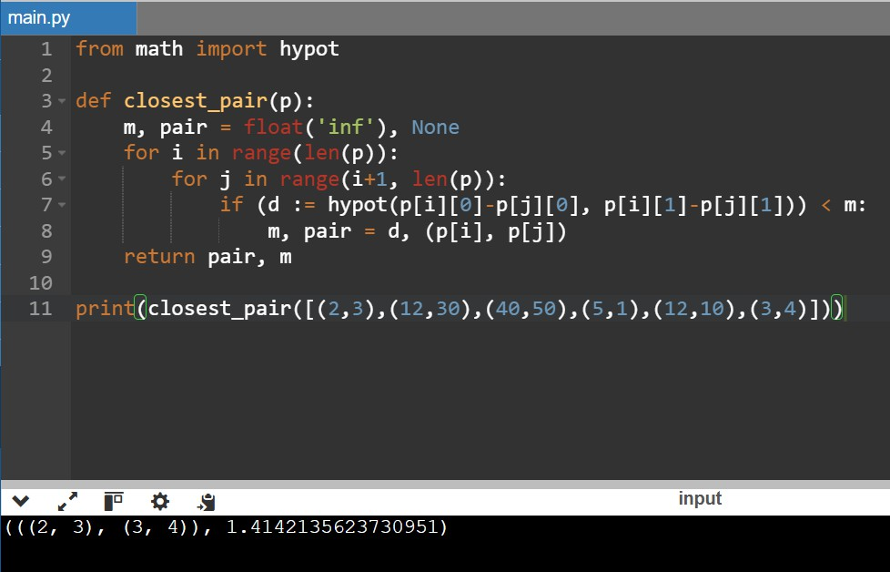

Part 2: Convex Hull (Brute Force) Algorithm:
- Take every pair of points (Pi, Pj)
- Form a line
- Check all other points lie on one side
- If yes → add edge to hull

Code (Python):
def convex_hull(p): h = set()
for i in range(len(p)):
for j in range(i+1, len(p)): pos = neg = 0
for k in range(len(p)): if k in (i, j): continue
v = (p[j][0]-p[i][0])*(p[k][1]-p[i][1]) - (p[j][1]-p[i][1])*(p[k][0]-p[i][0])
pos += v > 0 neg += v < 0
if pos == 0 or neg == 0: h.update([p[i], p[j]])
return list(h) print(convex_hull([(10,0),(11,5),(5,3),(9,3.5),(15,3),(12.5,7),(6,6.5),(7.5,4.5)]))

Implementation:
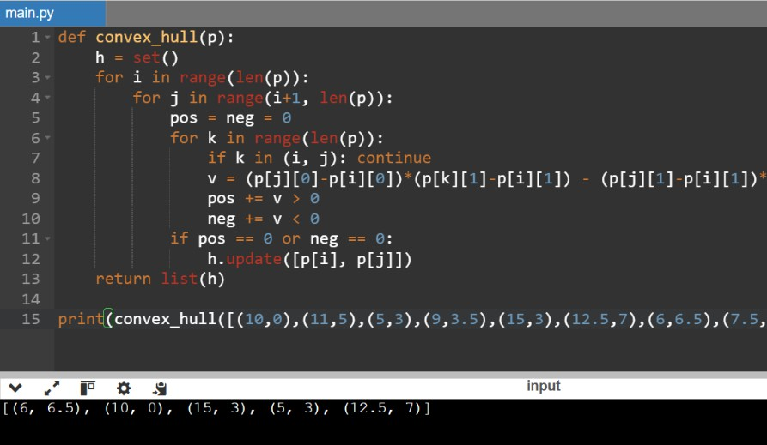

Result: Closest pair (O(n²)), convex hull (O(n³)), collinear points → only endpoints kept.

Write a program that finds the convex hull of a set of 2D points using the brute force approach.

Aim:
To find the convex hull of a set of 2D points using brute force approach.

Algorithm:
- Take every pair of points
- Form a line between them
- Check all other points lie on one side
- If yes, include those points in hull
- Return all hull points

Code (Python):
def convex_hull(p): h = set()
for i in range(len(p)):
for j in range(i+1, len(p)): pos = neg = 0
for k in range(len(p)): if k in (i, j): continue
v = (p[j][0]-p[i][0])*(p[k][1]-p[i][1]) - (p[j][1]-p[i][1])*(p[k][0]-p[i][0])
pos += v > 0 neg += v < 0
if pos == 0 or neg == 0: h.update([p[i], p[j]])
return list(h)

# Example
points = [(10,0),(11,5),(5,3),(9,3.5),(15,3),(12.5,7),(6,6.5),(7.5,4.5)]
print(convex_hull(points))

Implementation:
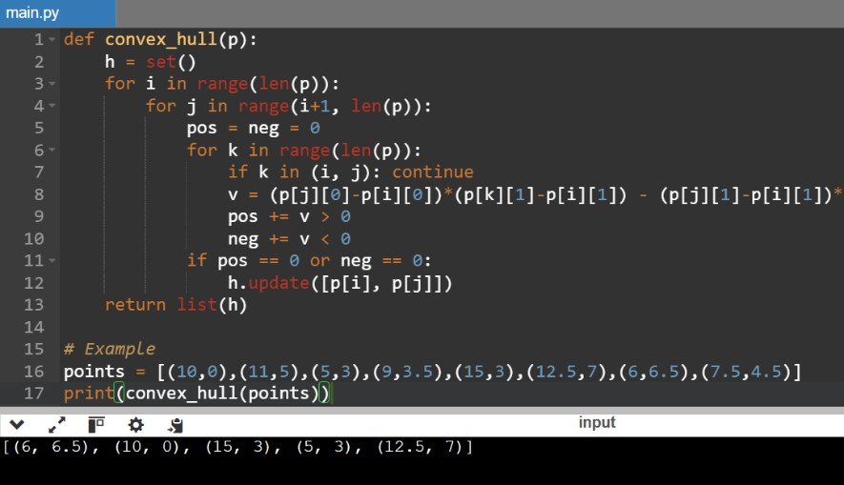

Result: Convex hull points are found successfully using brute force method.

  - You are given a list of cities represented by their coordinates. Develop a program that utilizes exhaustive search to solve the TSP. The program should:

    - Define a function distance (city1, city2) to calculate the distance between two cities (e.g., Euclidean distance).
Aim:
To solve the Traveling Salesman Problem (TSP) using exhaustive search.

Algorithm:
- Generate all possible permutations of cities
- Calculate total distance for each route
- Select the route with minimum distance

Code (Python):
from itertools import permutations from math import hypot
def tsp(c): best = min(
((sum(hypot(p[i][0]-p[i+1][0], p[i][1]-p[i+1][1]) for i in range(len(p)-1)) +
hypot(p[-1][0]-p[0][0], p[-1][1]-p[0][1])), p)
for p in permutations(c)
)
return best[1], best[0] print(tsp([(0,0),(1,2),(3,1),(2,3)]))

Implementation:
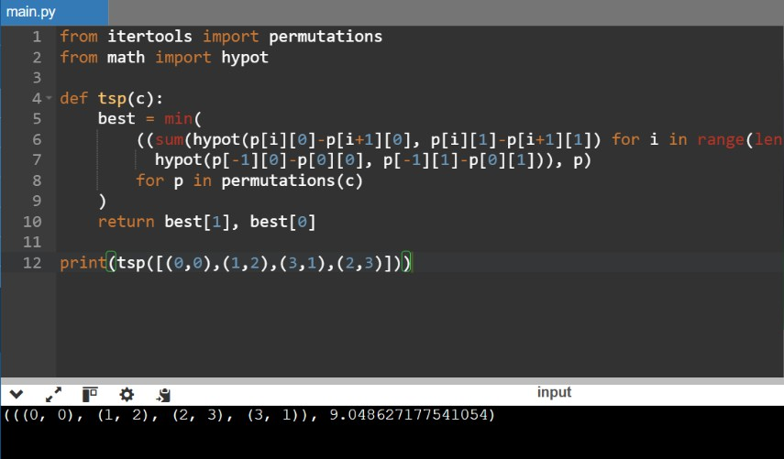

Result: The shortest possible route visiting all cities is found using exhaustive search.

Implement a function tsp(cities) that takes a list of cities as input and performs the following:

Aim:
- Generate all possible permutations of the cities (excluding the starting city) using itertools.permutations.
- For each permutation (representing a potential route):
- Calculate the total distance traveled by iterating through the path and summing the distances between consecutive cities.
- Keep track of the shortest distance encountered and the corresponding path.
- Return the minimum distance and the shortest path (including the starting city at the beginning and end).

To implement TSP using permutations and find the shortest path.

Algorithm:
  - Fix the starting city
  - Generate permutations of remaining cities
  - Return shortest path with start & end same

Code (Python):
from itertools import permutations from math import hypot
def tsp(c): s = c[0]
best = min(
(sum(hypot(p[i][0]-p[i+1][0], p[i][1]-p[i+1][1]) for i in range(len(p)-1)), p) for p in ((s,)+perm+(s,) for perm in permutations(c[1:]))
)
return best print(tsp([(0,0),(1,2),(3,1),(2,3)]))

Implementation:
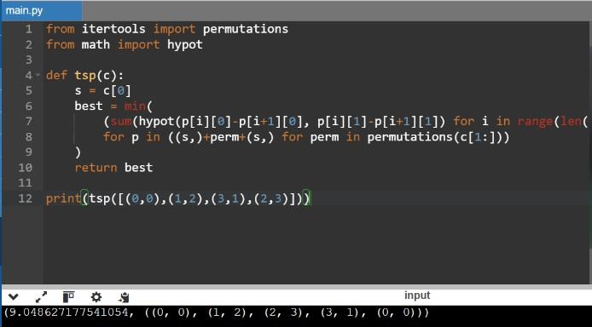
Result: Minimum distance and shortest path (start → cities → start) are found successfully.

Include test cases with different city configurations to demonstrate the program's functionality. Print the shortest distance and the corresponding path for each test case.

Aim:
To test the TSP program with different city configurations.

Code (Python):
from itertools import permutations from math import hypot

tsp = lambda c: min(
(sum(hypot(p[i][0]-p[i+1][0], p[i][1]-p[i+1][1]) for i in range(len(p)-1)), p) for p in ((c[0],)+perm+(c[0],) for perm in permutations(c[1:]))
)

for i,t in enumerate([[(0,0),(1,2),(3,1),(2,3)],[(0,0),(2,2),(3,3)],[(1,1),(4,5),(7,2),(6,6)]],1):
print(f"Test {i}:", tsp(t))

Implementation:
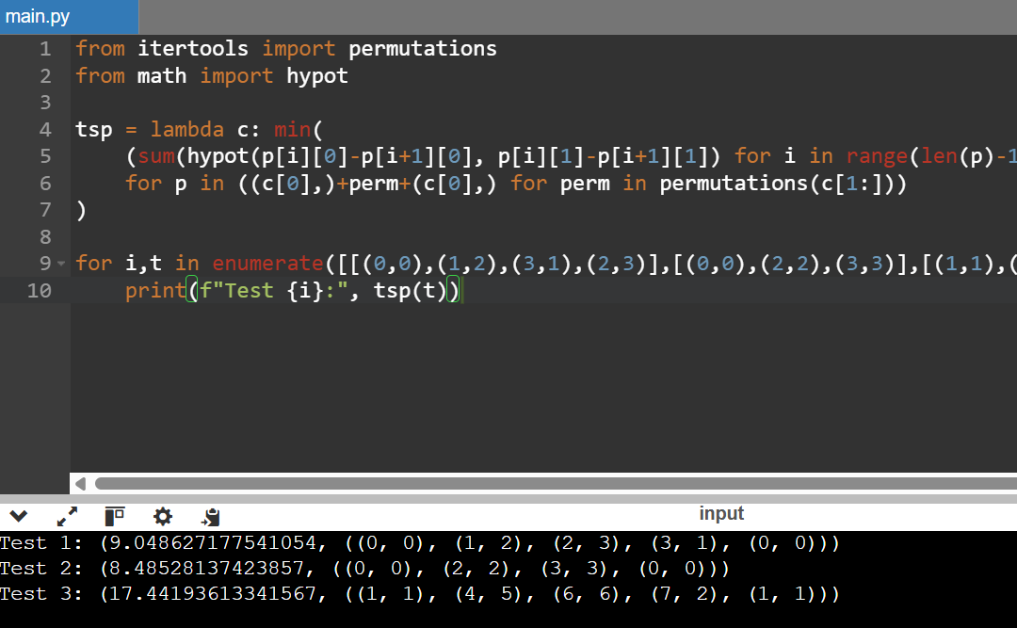

Result: Shortest distance and corresponding path are printed for each test case successfully.
  - You are given a cost matrix where each element cost[i][j] represents the cost of assigning worker i to task j. Develop a program that utilizes exhaustive search to solve the assignment problem. The program should Define a function total_cost(assignment, cost_matrix) that takes an assignment (list representing worker-task pairings) and the cost matrix as input. It iterates through the assignment and calculates the total cost by summing the corresponding costs from the cost matrix Implement a function assignment_problem(cost_matrix) that takes the cost matrix as input and performs the following Generate all possible permutations of worker indices (excluding repetitions).

Aim:
To solve the Assignment Problem using exhaustive search.

Algorithm:
- Generate all permutations of task assignments
- Calculate total cost for each assignment
- Track minimum cost and best assignment
- Return optimal assignment and cost

Code (Python):
from itertools import permutations

assignment_problem = lambda c: min( (sum(c[i][p[i]] for i in range(len(c))), p) for p in permutations(range(len(c)))
)
print(assignment_problem([[9,2,7],[6,4,3],[5,8,1]]))

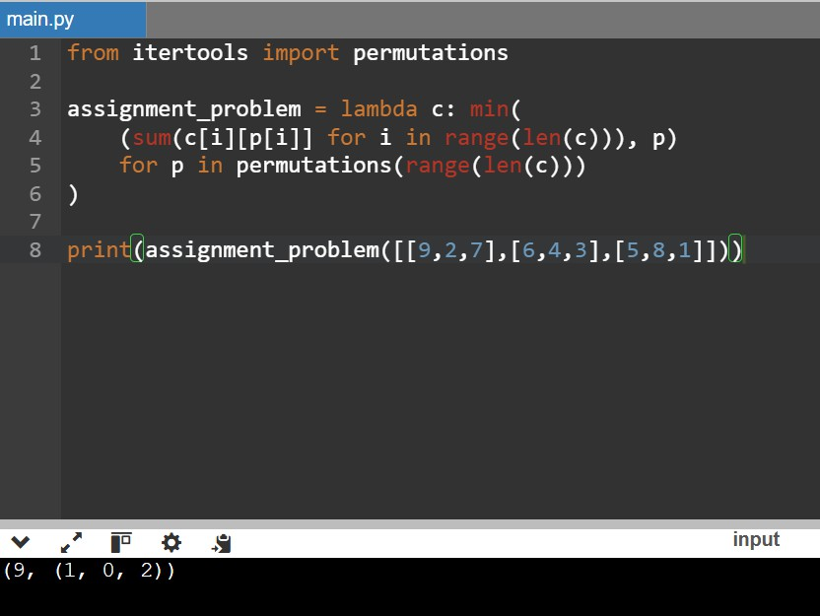
Implementation:

Result: Optimal assignment and minimum cost are found using exhaustive search.

  - You are given a list of items with their weights and values. Develop a program that utilizes exhaustive search to solve the 0-1 Knapsack Problem. The program should: Define a function total_value(items, values) that takes a list of selected items (represented by their indices) and the value list as input. It iterates through the selected items and calculates the total value by summing the corresponding values from the value list. Define a function is_feasible(items, weights, capacity) that takes a list of selected items (represented by their indices), the weight list, and the knapsack capacity as input. It checks if the total weight of the selected items exceeds the capacity.

Aim:
To solve the 0-1 Knapsack Problem using exhaustive search.

Algorithm:
- Generate all subsets of items
- Check if subset weight ≤ capacity
- Calculate total value
- Track maximum value and best subset
- Return optimal selection

Code (Python):
from itertools import combinations knapsack = lambda w,v,c: max(
((sum(v[i] for i in s), s) for r in range(len(w)+1)
for s in combinations(range(len(w)), r) default=(0,())
)
print(knapsack([2,3,4,5],[3,4,5,6],5))

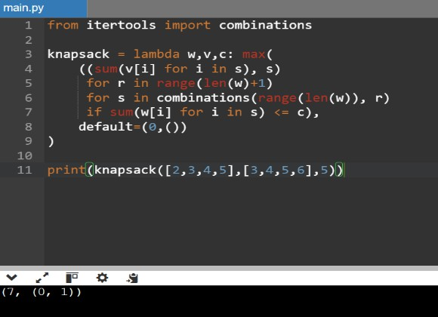
Implementation:

Result: Maximum value and optimal item selection are found using exhaustive search.

